# Task B: Views & Subqueries

## 1. **Create View: `vw_recent_orders_30d`**    - View of orders placed in the **last 30 days** from `CURRENT_DATE`, excluding `cancelled`.    - Columns: order_id, customer_id, order_date, status, order_total (sum of items).

**CREATE** **OR** **REPLACE** VIEW training_ecom.vw_recent_orders_30d **AS**

**SELECT**

o.order_id,

o.customer_id,

o.order_date,

o.status,

SUM(oi.quantity * oi.unit_price) **AS** order_total

**FROM** training_ecom.orders o

**JOIN** training_ecom.order_items oi **ON** o.order_id = oi.order_id

**WHERE** o.order_date >= CURRENT_DATE - **INTERVAL** '30 days'

**AND** o.status != 'cancelled'

**GROUP** **BY** o.order_id, o.customer_id, o.order_date, o.status;

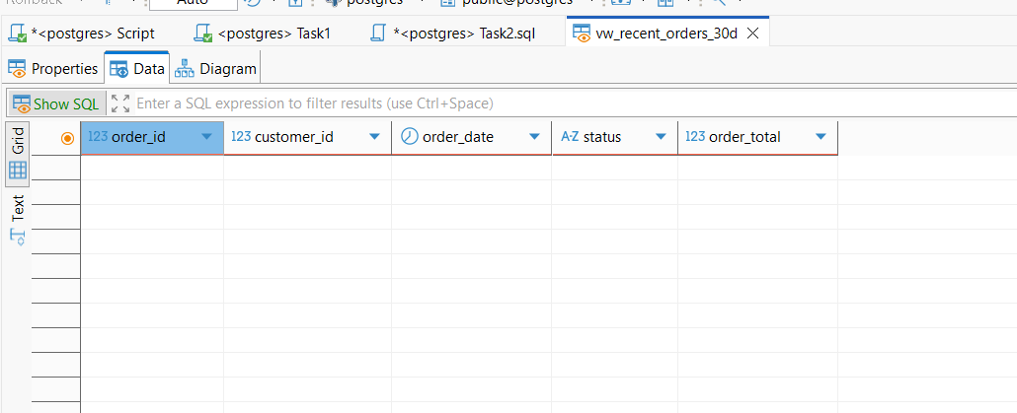

**2. **Products Never Ordered**  
   - Using a subquery, list products that **never** appear in `order_items`.**

**SELECT**

*p*.product_id,

*p*.product_name,

*p*.category,

*p*.unit_price

**FROM** training_ecom.products *p*

**WHERE** *p*.product_id **NOT** **IN** (

**SELECT** **DISTINCT** product_id **FROM** training_ecom.order_items

);

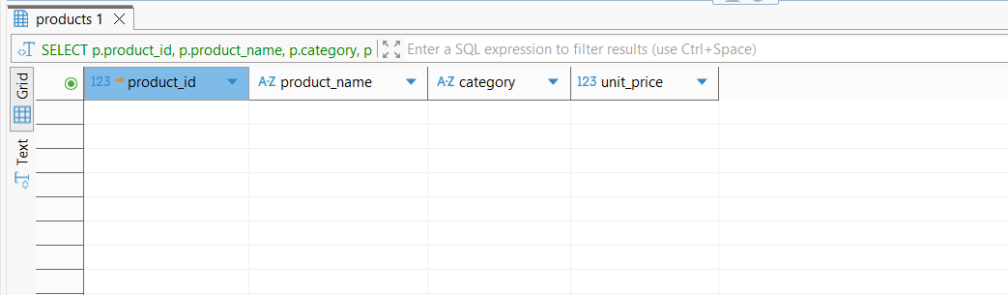

## 3. **Top Category by City**    - For each `city`, find the **single category** with the highest total revenue. Use an inner subquery or a view plus a filter on rank.

**SELECT**

city,

category,

*total_revenue*

**FROM** (

**SELECT**

*c*.city,

*p*.category,

**SUM**(*oi*.quantity * *oi*.unit_price) **AS** *total_revenue*,

**RANK**() **OVER** (

**PARTITION** **BY** c.city

**ORDER** **BY** **SUM**(oi.quantity * oi.unit_price) **DESC**

) **AS** *revenue_rank*

**FROM** training_ecom.customers *c*

**JOIN** training_ecom.orders *o* **ON** *c*.customer_id = *o*.customer_id

**JOIN** training_ecom.order_items *oi* **ON** *o*.order_id = *oi*.order_id

**JOIN** training_ecom.products *p* **ON** *oi*.product_id = *p*.product_id

**WHERE** *o*.status != 'cancelled'

**GROUP** **BY** *c*.city, *p*.category

) **AS** *city_category_revenue*

**WHERE** *revenue_rank* = 1

**ORDER** **BY** city;

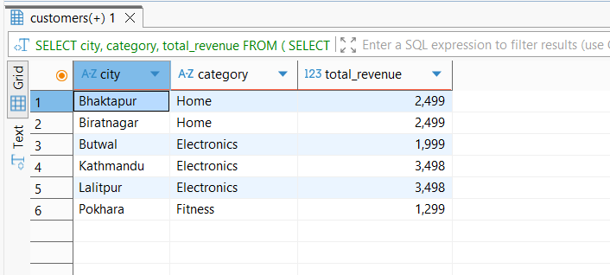

## 4. **Customers Without Delivered Orders**    - Using `NOT EXISTS`, list customers who have **no orders** with status `delivered`.

**SELECT**

*c*.customer_id,

*c*.full_name

**FROM** training_ecom.customers *c*

**WHERE** **NOT** **EXISTS** (

**SELECT** 1

**FROM** training_ecom.orders *o*

**WHERE** *o*.customer_id = *c*.customer_id

**AND** *o*.status = 'delivered'

)

**ORDER** **BY** *c*.customer_id;

